- Root Element
This is the Primary node. The only valid child elements are Fields and Documents.
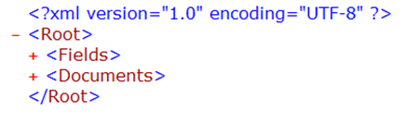
- Fields Element
This element defines a list of metadata fields that will be loaded with documents. Any document metadata fields to be loaded must be defined in the Fields Element. Any metadata field not defined will not be loaded with the documents. The only valid child element is Field.
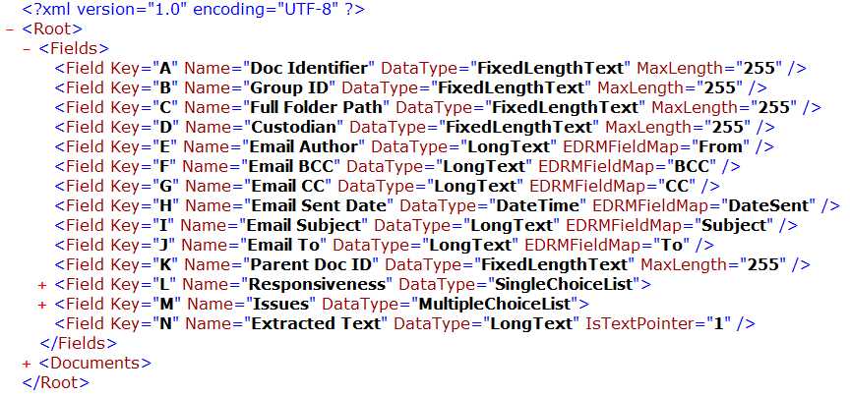

- Field Element
This element defines each field. The only valid child element is Choices.

  - Key (string, required) – a unique value used to identify the field
  - Name (string, required) – the name of the field
  - DataType (string, required) – the type of field
Valid DataTypes:
    - Text
    - Integer
    - DateTime
    - Decimal
    - Boolean
    - LongInteger
    - LongText
    - FixedLengthText
    - SingleChoiceList
    - MultipleChoiceList
  - MaxLength (integer) – maximum length allowed in the field
  - EDRMFieldMap (string) – optionally map a user-defined field to a standard EDRM field
  - AllowHyperlink (Boolean) – identifies whether hyperlinks are allowed
  - IsTextPointer (Boolean) – identifies whether the field value is contained in a file

- Choices Element
This element defines all available choices in single or multiple choice fields. The only valid child element is Choice.
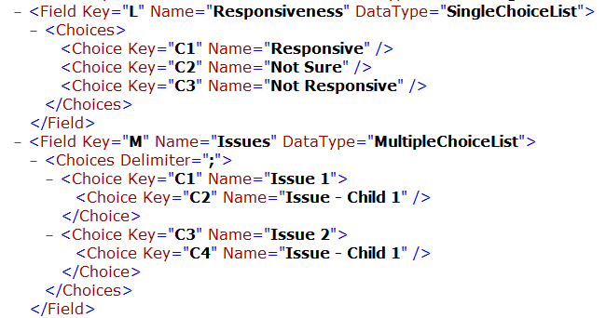
  - Delimiter (string, required for fields of DataType = MultipleChoiceList) – identifies the character to be used to separate choices in multiple choice field values

- Choice Element
This element defines a choice in single choice or multiple choice fields. The only valid child element is Choice to establish the relationship between a child choice and its parent choice.
  - Key (string, required) – a unique key used to identify the choice
  - Name(string, required) – the name of the choice

Example of a single choice field definition:
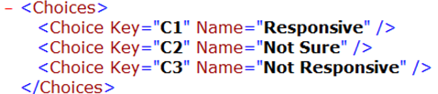

Example of a multiple choice field definition with nested choices:
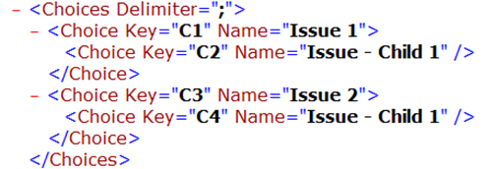

- Documents Element
This element defines a list of documents to be loaded and their metadata. The only valid child element is Document.
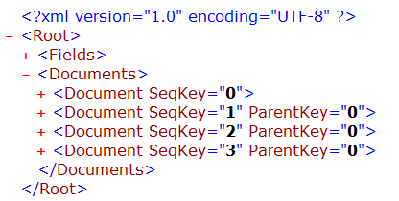

- Document Element
This element defines a single document. The only valid child elements are FieldValues and Files.
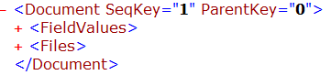

  - SeqKey (integer, required) – defines the order in which the document should be loaded. Documents must be listed in order by SeqKey.
  - ParentKey (integer) – defines the parent of the document. The ParentKey must be less than the SeqKey to verify that the parent is loaded before the child document.

Example of a document with no parent:

Example of a document with a parent document which is the document with a SeqKey = 0:

- FieldValues Element
This element lists the document’s metadata to be loaded. Valid child elements are any Keys that were previously defined in the Fields element. The element should include the corresponding Key defined in the Fields element and the field’s value.
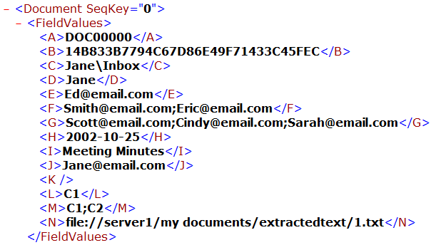

Example of defining the value of a multiple choice field:
The Field is defined as:
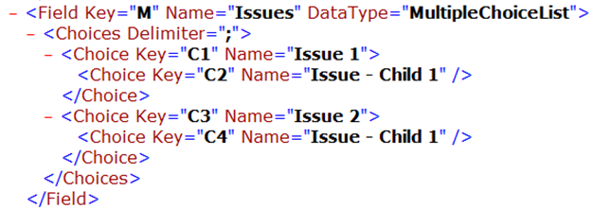

The FieldValue is defined as the following, meaning that choice Issue 1 and it’s nested choice Issue – Child 1 will be set in the Issues field:

- Files Element
This element includes any files to be loaded with the document. The only valid child elements are Native and Images.
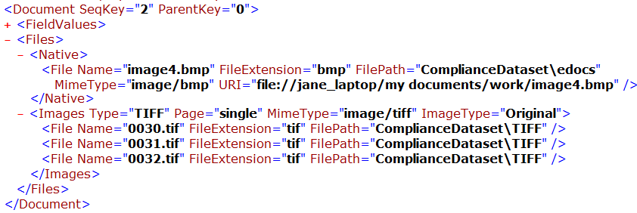

- Native Element
This element defines the document native file to be loaded. The only valid child element is File.

- Images Element
This element defines the associated images to be loaded with each document. The only valid child element is File.
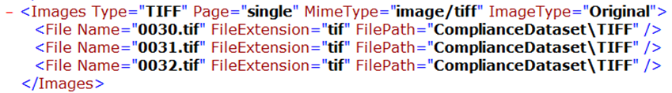
    - Type (string, required) – the type of image file
    - Page (string, required) – identifies whether the image is a single page or multiple pages
    - MimeType (string) – identifies the type of the file
    - ImageType (string, required) – type of image, either original or production

- File Element
This element defines each individual file. There are no valid child elements.

  - Name (string, required) – the full name of the file, including the file extension
  - FileExtension (string, required) – the extension of the file
  - FilePath (string)– the relative path where the file is being loaded from
  - MimeType (string)– identifies the MIME of the document
  - URI (string) – identifies the absolute path to the original file

